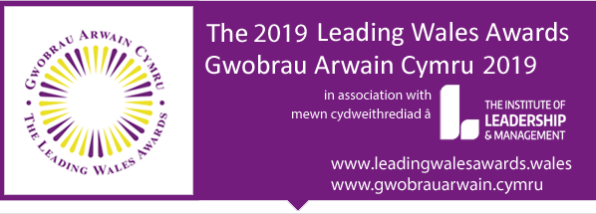
Nomination form: Leadership in the Public Sector
Category description: Nominations in this category are open to any individuals who have a leadership role at whatever level of responsibility within any Public Sector organisation in Wales (e.g. Local Authorities, Schools, NHS, Colleges of FE, Higher Education, Public Bodies etc)
Section 1: Your nominee’s contact data
Name ……….
Email ……..
Mobile ….
Role …..
Organisation
Would you like to receive the small number of promotional emails relating to the nomination process from Leading Wales Awards? YES /NO
Section 2: Your own contact data as nominator
Name ……….
Email ……..
Mobile ….
Role …..
Organisation
Would you like to receive the small number of promotional emails relating to the nomination process from Leading Wales Awards? YES /NO
Would you like to receive information relating to free access of My Leadership assessment from The Institute of Leadership & Management? YES /NO

Section 3: Your connection with your nominee
How do you know the person you are nominating? …….
It is a condition of entry that you discuss your nomination with the person you are nominating for the Awards and that he /she has given his/her agreement for you to nominate him / her. Please confirm that you have done this YES / NO

Section 4: Judging Criteria

The judges are seeking nominations of individuals at all levels of responsibility whose leadership is inspiring and transforming. Individuals whose leadership:

- Influences and engages by
- Portraying high levels of integrity and ethics through consistent behaviours
- Being brave and demonstrating a willingness to take appropriate risks, challenging the status quo
- Raising levels of morale, well-being and engagement and addressing and resolving conflict

………………………………………………………………………………………………………………………………
- Inspires and motivates
- Others to achieve unexpected and remarkable results; to achieve more than they believed they could
- Hence mobilising others in developing a shared vision and goals; motivating others to work together and deliver the best outcomes through collaboration and partnership

………………………………………………………………………………………………………………………………
- Supports creativity and innovation by
- Working with others to identify areas of necessary change, approaching problems in new ways
- Working collaboratively to seek new ideas and solutions and fosters an environment to support this

……………………………………………………………………………………………………………………………….
- Treats everyone as individuals by
- Building trust and trusted relationships both within and beyond organisational boundaries; giving employees autonomy over specific jobs and decision making for which they have been trained
- Paying special attention to individual needs for achievement and growth and ensuring colleagues are developed to successively higher levels of potential

…………………………………………………………………………………………………………………………………
- Has measurable impact and
- Demonstrates that impact and achievement
Section 5: Please complete all questions given below:
(Important advice: please complete your answers by providing evidence that demonstrates the criteria given above!)
- Describe the organisation’s activity together with an outline of your nominee’s leadership role and responsibilities within the organisation or team or project (200 words max)

- Describe how your nominee influences and engages employees and stakeholders (maximum 300 words)

- Describe how s/he inspires and motivates employees and stakeholders (maximum 300 words)

- Explain how your nominee encourages and supports colleagues to be as creative and innovative as possible in identifying solutions (maximum 300 words)

- Describe the ways in which they treat everyone as individuals, and with individual consideration (maximum 300 words)

- Give 3 examples of the achievements and impact of his / her leadership within the organisation, or team or project (each one of 100 words max)
a)

b)

c)

Please return via email to:
leadingwalesawards@learningpathways.info by midnight on Friday June 7th 2019
If you need further guidance or assistance please phone Barbara Chidgey, Executive Chair, on 07989385114.

